SciVR app instructions
1. Download the SciVR app to your smartphone. You will need mobile data or wifi / internet.
Search for the SciVR app in the App Store or Google Play (make sure you know the password for your account) or follow the links at www.scivr.com.au

It might take a few minutes to download the app, depending on your internet quality.
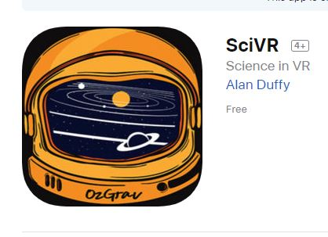
2. Open the SciVR app and turn your phone sideways to landscape view.
If you have a mini VR headset, choose VR mode.
If you don’t have a mini VR headset, you can use the app without VR mode. Magic Window mode lets you move your phone/device around to see up and down. Touch mode allows you to touch the screen and scroll to look around.
VR mode has 2 images. Non-VR mode has 1 image.
The rest of these instructions assume you are using VR mode.
3. Open out the mini VR headset. Clip the VR headset onto your phone.
Line up the headset in the middle of the 2 images. If your phone has a case, you may need to take the case off.
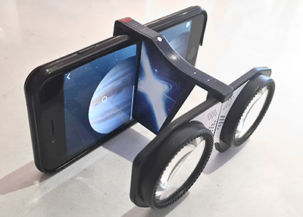

4. Hold the phone and VR headset up to your eyes. Look through the lenses. Move your phone around to look.
You can look up, down and behind you. Make sure you are safe and don’t fall over.
Move the circle over menu items or hotspots to select, then tap.
Move the grey circle over the object you want to select. When the grey circle turns green, you can select this object. To select, tap the screen with your finger. You can tap anywhere on the screen.
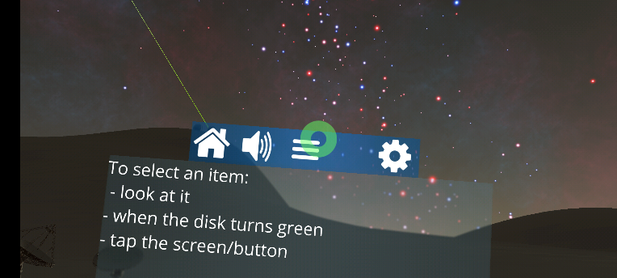
5. To calibrate the VR lenses, tap the gear/cog icon, then “Select Headset”
then access the camera and scan this QR code:

Skip this step if you are using the app in non-VR mode (single screen).
This will pair your phone with the Lion VR mini viewer.
You may need to download the Google Cardboard app (internet connection required).

Extra: You can minimise and maximise the menu by tapping the menu button.
You can move the menu to a different place. Tap the menu button and drag by moving your phone. If you tap and hold anywhere for 4 seconds, the menu comes to you.
Extra: You can turn on a text reader to hear the words. Tap the cog icon, then check the box for “Read Text”.
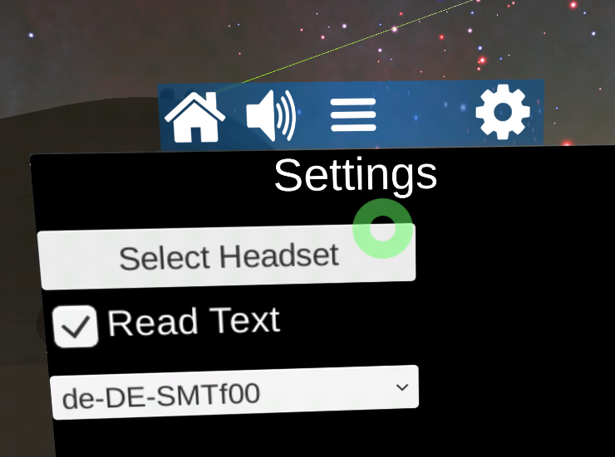
Extra: You can mute or pause the sound with the volume button

